Part B Q1 Implement and Secure Switch Port Access using Cisco Packet Tracer

Scenario
You are a Network Administrator working in a small office where you need to secure the switch ports, ensuring that only authorized devices can access the network. The office uses a Cisco Layer-2 switch. Your task is to configure the switch for secure port access and enable SSH for remote management. Additionally, you need to disable unused ports to prevent unauthorized access.
Output & config:

SSH connection working:
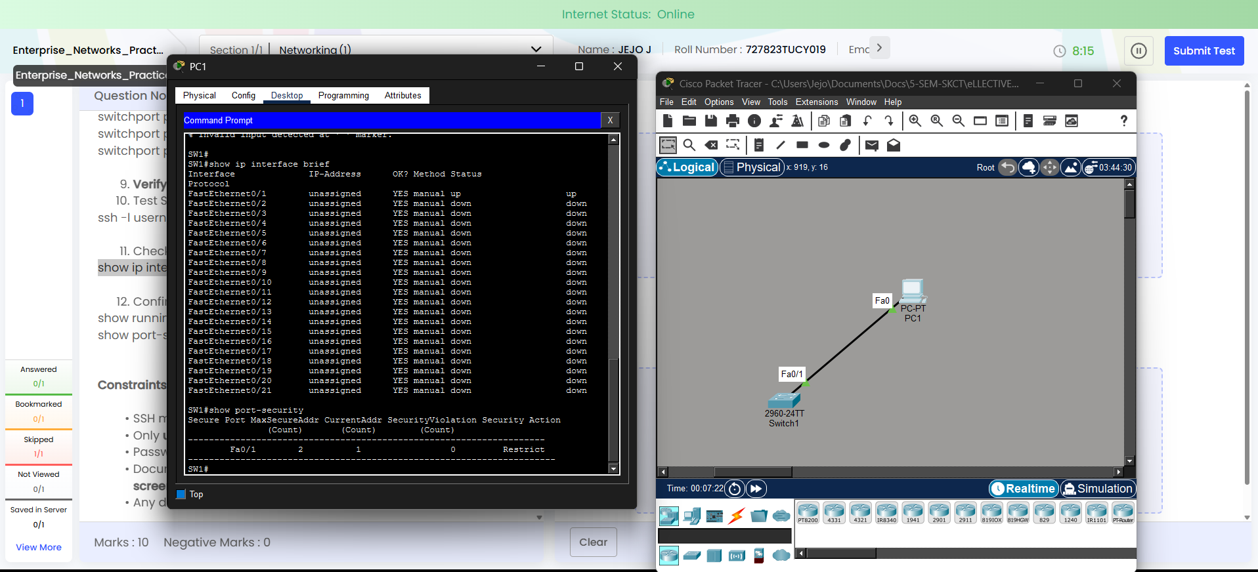

Name: Jejo J
Roll : 727823tucy019

